Homework 3: Team Presentation – 20 Points

Your Homework 3 is the continuation of Homework 1, and Homework 2. So you will continue to work with the same teams.

Learning Objective
The learning objective for this HW-3 is to give you a real-time exposure by implementing software testing a software and deploying it by using Implementation, Testing and Deployment Phase from SDLC.
Deliverables
- PPT.
Video Presentation and Slides (Switch on your cameras for Video presentation):
Each team will have their own time limit for video presentation that includes slides showing the following:

- Title slide, including:
  - Project title
  - Date
  - List of all team member names
- Brief overview/description of the project
- Present Project Status
- Test Plan
4.1 Test Approach: Mention what testing methods will be performed.
Ex: Unit Testing, Integration Testing, Regression Testing

4.2 Acceptance criteria: Mention all the requirements to be met to move from testing to deployment.
Ex:
No critical or high-severity defects remain open.
100% of critical test cases must pass, and 95% of overall test cases must pass.
The system meets all requirements outlined in the project specification.

4.3 Test Environment: Mention Hardware and software needed to do the testing process.

  - Test Data: Mention what kind of testing data is needed to test your requirements.

4.5 Test Cases: Number of test cases planned for each requirement

4.6 Resource Planning. Name and responsibility

Ex:
Nethra: QA Lead: Responsible for planning, coordination, and reporting.
Sai: Tester: Conduct unit and regression testing.
Amit: Tester: Conduct integration and regression testing.

  - Defect Management: Mention how do you manage to work with defects

Ex: Defects will be logged in Jira, categorized by severity, and assigned to developers.
Status updates will follow a workflow: New → Open → In Progress → Fixed → Verified → Closed.

- Software Implementation (Developer)
  - Demonstrate how you plan to implement the project and perform unit testing.
  - Mention the programming language you want to use
  - What kinds of resources do you think you might need (Ex: Hardware, access levels for different software)
  - Implement your software and show your software implementation
  - Resolve the bugs raised by the testers and mention how you resolved the bugs

- Test Script (Tester)
Show your test cases for each requirement.

Ex:
    - Sample test case for the requirement FR1: User Login
Test Case ID: | TC_01
Test Scenario | FR1: User Login
Test Status – Pass/Fail | N/A
Test Data | Username: xyz@gmail.com password: 123456
Browser | Google chrome
Test Step | Expected Result for Each Test Step
User should go to website xyz.co.in and see the web page | System should allow the user to navigate to URL xyx.co.in and display the web page
User should be able to see username and enter xyz@gmail.com | System should show username and should allow user to enter xyz@gmail.com
User should be able to see password and enter 123456 | System should show password and should allow user to enter 123456 without displaying
User should be able to click on Login Button | System should allow to click on Login button and navigate to Home page

- Test report (Tester).
- mention
  - The number of test cases planned vs executed.
  - The number of test cases passed/failed.
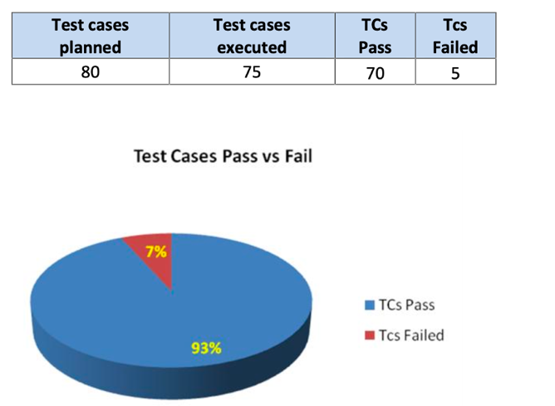

  - Number of defects identified and their Status & Severity
    - Note: Closed means defects are resolved and open means defects are not resolved yet
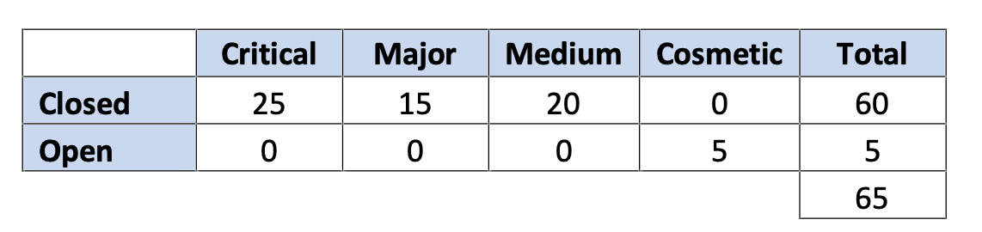
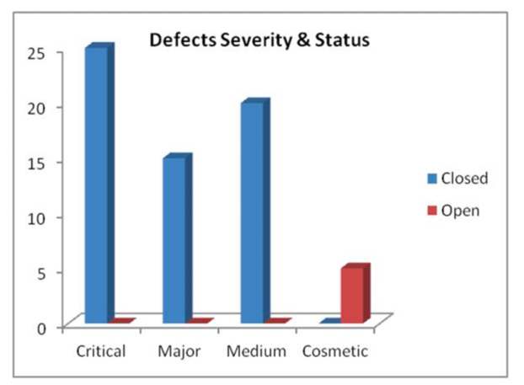

- Implementation Milestones
  - Mention if you are still on track delayed or ahead of your initial plan.

- Team Assignments and Responsibilities
  - List each member of the team’s responsibility in detail about what they will be doing for their present homework-4
    - For Example, Person A: played the role of a project manager and he monitored everything was going on track for homework -4
    - Person B: Played the role of a developer and planned for software implementation for homework -4
    - Person C: Played the role of a tester and had the complete test plan for homework -4
    - Person D: Played the role of a tester and had written few sample test scripts for homework -4
- Mention if you followed all below ethical guidelines that govern computing practices, including those related to privacy, security, intellectual property, and equity
- Respect for Ownership: Honor copyrights, patents, trademarks, and software licenses if you using others.
- Avoiding Plagiarism: Acknowledge the original creators of software, designs, or algorithms and add them in your references.
- Confidentiality: Safeguard sensitive data like passwords from unauthorized access or disclosure to others for your projects.
- Promoting Diversity: Create tools and environments that consider diverse user needs, cultures, and backgrounds.
- Recording link of your presentation
Rubrics Scale:
- Title slide – 0.25 points
- Brief overview/description of the project – 0.25 points
- Present project status – 2 points
- Test plan – 3 points
- Software Implementation (Developer) – 5 points
- Test Script (Tester) – 3 points.
- Test report – 2 points.
- Implementation Milestones – 0.5 point
- Team Assignments and Responsibilities – 0.5 point
- Mention if you followed all the ethical guidelines that govern computing practices, including those related to privacy, security, intellectual property, and equity – 0.5 point
- Recording Link – 3 points

